**Lets Upgrade**

Cyber security (Day 4)

1.Finding mail servers of :-

* IBM.com
* WIPRO.com

**COMMAND USED**-

nslookup

Set type=mx

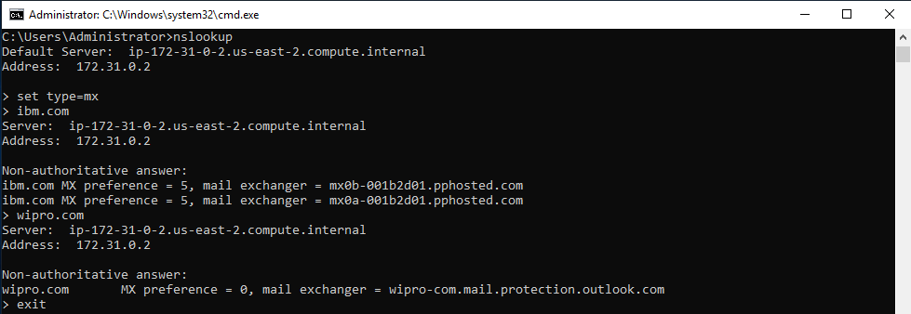

2. Finding locations, where these email servers are hosted

**IBM.com**

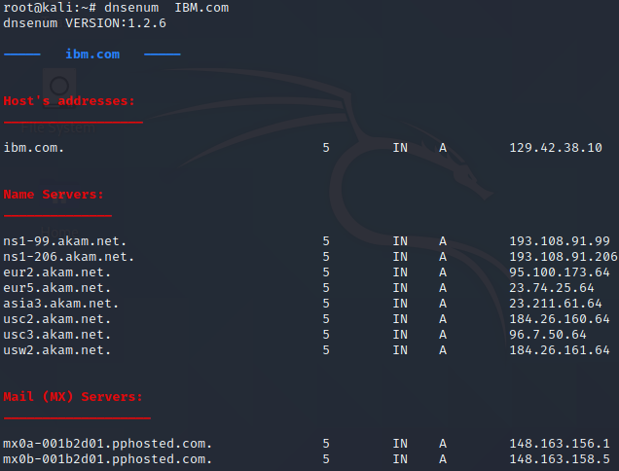

* 148.163.156.1

**Location**- United States of America

* 148.163.158.5

**Location-** United States of America

**WIPRO.com**

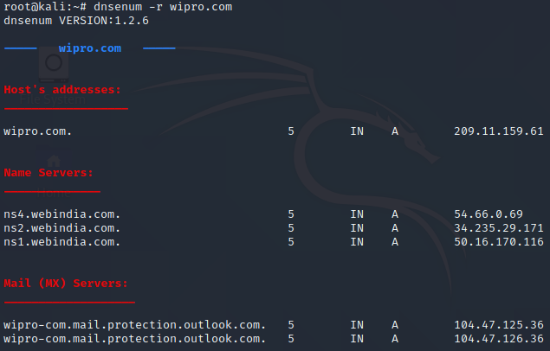

* 104.47.125.36

**Location**- Singapore

* 104.47.126.36

**Location-** Korea

3. To find port numbers open for 203.163.23

No response from host

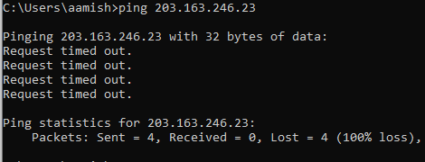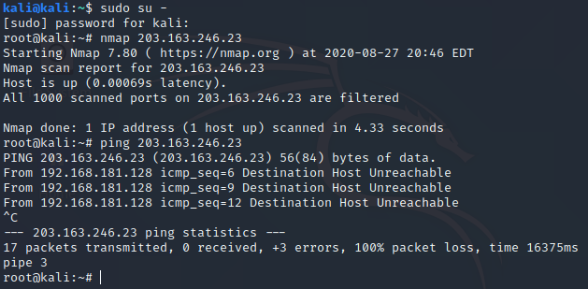

4. To install Nessus in VM and scan for CVE

Not able to run Nessus in AWS, due to less ram (i.e 1 GB)

-Aamish Abrar